Project Design Phase-II

Technology Stack (Architecture & Stack)

|  |  |
| --- | --- |
| Date | 04 November 2022 |
| Team ID | PNT2022TMID50401 |
| Project Name | DemandEst_ AI Powered Food Demand Forecasting. |
| Maximum Marks | 4 Marks |

Technical Architecture:

The Deliverable shall include the architectural diagram as below and the information as per the table1 & table 2 **Example: Order processing during pandemics for offline mode**

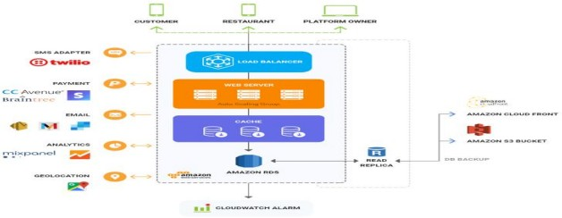

Table-1 : Components & Technologies:

|  |  |  |  |
| --- | --- | --- | --- |
| **S.No** | **Component** | **Description** | **Technology** |
| 1. | Customer | By using Mobile App and Through online registration. | HTML, CSS, JavaScript . |
| 2. | Restaurant | It includes all the goods and services that the restaurant meals. | Online transactions |
| 3. | Geolocation | Used to reach the destination. | Google map,user address. |
| 4. | Platform owner | Wait for the delivery of food. | Mobile phones and online websites. |

|  |  |  |  |
| --- | --- | --- | --- |
| 5. | Database Analytics | Data Type, Configurations etc. | MySQL, NoSQL, etc. |
| 6. | Cloud Database | Database Service on Cloud | IBM DB2, IBM Cloudant etc. |
| 7. | File Storage | User information. | IBM Block Storage or Other Storage Service or Local Filesystem |
| 8. | Amazon s3 bucket | Storage with data availability. | HTTP interface . |
| 9. | Cloudwatch alarm | Purpose of External API used in the application | Notification services. |

Table-2: Application Characteristics:

|  |  |  |  |
| --- | --- | --- | --- |
| **S.N**  **o** | **Characteristics** | **Description** | **Technology** |
| 1. | Open-Source Frameworks | Google chrome, online websites | Technology of Open Source framework |
| 2. | Security Implementations | Authentications through OTP. | Through mobile phones. |
| 3. | Scalable Architecture | Based on quality. Based on taste. | Quality assurance Quality control. |
| 4. | Availability | Available through online | Online system |
| 5. | Performance | Provide qualitative food Encourage customer loyalty. Boost sales. | Testing shows preference for mistakes. Detecting the defect within a software. |